
Faculty: Engineering and Technology

School of Computer Engineering & Technology

Programme: B.Tech Computer Sc. & Engineering

Name: Devanshu Surana

Roll No.: 23

Prn:1032210755

Panel: C batch:C1

Lab A3: Implement Diffie-Hellman Key Exchange Algorithm using python or java or C++ Objective of Lab
- To introduce the fundamental concepts of discrete logarithmic problem, public key encryption , man in the middle attack and implement Diffie-Hellman Key Exchange Algorithm

Theory:

Diffie-Hellman algorithm:

The Diffie-Hellman algorithm is being used to establish a shared secret that can be used for secret communications while exchanging data over a public network using the elliptic curve to generate points and get the secret key using the parameters.

For the sake of simplicity and practical implementation of the algorithm, we will consider only 4 variables, one prime P and G (a primitive root of P) and two private values a and b.
P and G are both publicly available numbers. Users (say Alice and Bob) pick private values a and b and they generate a key and exchange it publicly. The opposite person receives the key and that generates a secret key, after which they have the same secret key to encrypt

Example of Using Diffie-Hellman Key Exchange Algorithm Step 1: Alice and Bob get public numbers P = 23, G = 9

Step 2: Alice selected a private key a = 4 and

Bob selected a private key b = 3

Step 3: Alice and Bob compute public values

Alice: x =(9^4 mod 23) = (6561 mod 23) = 6

Bob: y = (9^3 mod 23) = (729 mod 23) = 16

Step 4: Alice and Bob exchange public numbers

Step 5: Alice receives public key y =16 and

Bob receives public key x = 6
Faculty: Engineering and Technology

School of Computer Engineering & Technology

Programme: B.Tech Computer Sc. & Engineering

Step 6: Alice and Bob compute symmetric keys

Alice: ka = y^a mod p = 65536 mod 23 = 9

Bob: kb = x^b mod p = 216 mod 23 = 9

Step 7: 9 is the shared secret.

Algorithm

1. Initialization:

Both parties, Alice and Bob, agree on two publicly known values: a prime number (p) and a primitive root modulo p (g).

These values are typically agreed upon in advance and are available to anyone who wants to communicate securely.

- Private Key Generation:

Both Alice and Bob independently choose their private keys: Alice selects a secret integer "a."
Bob selects a secret integer "b."

These private keys are kept confidential and are not shared with anyone.

- Public Key Calculation:

Alice computes her public key (A) as follows: A = g^a mod p
Bob computes his public key (B) as follows: B = g^b mod p
Note that Alice and Bob perform these calculations independently and without sharing their private keys.

- Public Key Exchange:

Alice sends her public key (A) to Bob. Bob sends his public key (B) to Alice.

These public keys can be openly exchanged over the untrusted communication channel.

- Shared Secret Key Derivation:

Alice uses Bob's public key (B) and her private key (a) to derive the shared secret key

- as follows: s = B^a mod p
Bob uses Alice's public key (A) and his private key (b) to derive the shared secret key

- as follows: s = A^b mod p
These calculations are performed independently by Alice and Bob.
Faculty: Engineering and Technology

School of Computer Engineering & Technology

Programme: B.Tech Computer Sc. & Engineering

- Shared Secret Key:

Both Alice and Bob now have the same shared secret key (s).

This shared secret key can be used for secure communication between the two parties.

Code

def prime_checker(p):

- Checks If the number entered is a Prime Number or not if p < 1:
return -1

elif p > 1:

if p == 2:

return 1

for i in range(2, p):

if p % i == 0:

return -1

return 1

def primitive_check(g, p, L):

- Checks If The Entered Number Is A Primitive Root Or Not for i in range(1, p):
L.append(pow(g, i) % p) for i in range(1, p):
if L.count(i) > 1: L.clear() return -1
return 1
Faculty: Engineering and Technology

School of Computer Engineering & Technology

Programme: B.Tech Computer Sc. & Engineering

l = []

while 1:

P = int(input("Enter P : "))

if prime_checker(P) == -1:

print("Number Is Not Prime, Please Enter Again!")

continue

break

while 1:

G = int(input(f"Enter The Primitive Root Of {P} : "))

if primitive_check(G, P, l) == -1:

print(f"Number Is Not A Primitive Root Of {P}, Please Try Again!")

continue

break

# Private Keys

x1, x2 = int(input("Enter The Private Key Of User 1 : ")), int(

input("Enter The Private Key Of User 2 : "))

while 1:

if x1 >= P or x2 >= P:

print(f"Private Key Of Both The Users Should Be Less Than {P}!")

continue

break

# Calculate Public Keys
Faculty: Engineering and Technology

School of Computer Engineering & Technology

Programme: B.Tech Computer Sc. & Engineering

y1, y2 = pow(G, x1) % P, pow(G, x2) % P

# Generate Secret Keys

k1, k2 = pow(y2, x1) % P, pow(y1, x2) % P

print(f"\nSecret Key For User 1 Is {k1}\nSecret Key For User 2 Is {k2}\n")

if k1 == k2:

print("Keys Have Been Exchanged Successfully")

else:

print("Keys Have Not Been Exchanged Successfully")

Output Screen shots
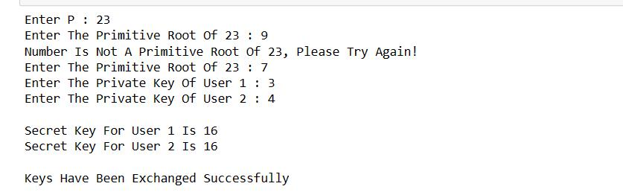

Conclusion: Thus, we have learned and implemented the Diffie-Hellman Key Exchange Algorithm successfully.

FAQs:

- What is Diffie Hellman Key Exchange
- What is Diffie Hellman most commonly used for?
- Is Diffie Hellman Symmetric algorithm
- Is Diffie Hellman secured and still used today
Faculty: Engineering and Technology

School of Computer Engineering & Technology Programme: B.Tech Computer Sc. & Engineering

